Automated Email System

Read Summary from DB
↓
Decision (Code)
↓
Generate Email (AI) {and separate email on basis of recipient whether to send it to doctor or patient}
{input summary and generate email on the basis of diff factors like anxiety level,depression_risk etc that AI generates on the basis of the summary provided}
↓
Send Email
↓
Save Logs

- Open 2 cmd always(virtual env activation) first the flask server(followup_service) and then to Generate Emails from DB(followup_worker)

C:\Users\Sanjeev Kumar\Desktop\HOPEQURE
venv\Scripts\activate
cd clinical-ai-system
then run service then open http://127.0.0.1:7000 fill input then Then run followup worker in another cmd

Day6: Making Clinical Data in Database Accessible via APIs(REST APIs using flask and ngrok)

Setup:
python followup_service.py(in main cmd)
./ngrok http 9000(open diff cmd in folder of where ngrok is)

changed port to 9000 for flask app also(followup_service.py)
till here in hopequre_email_system in git

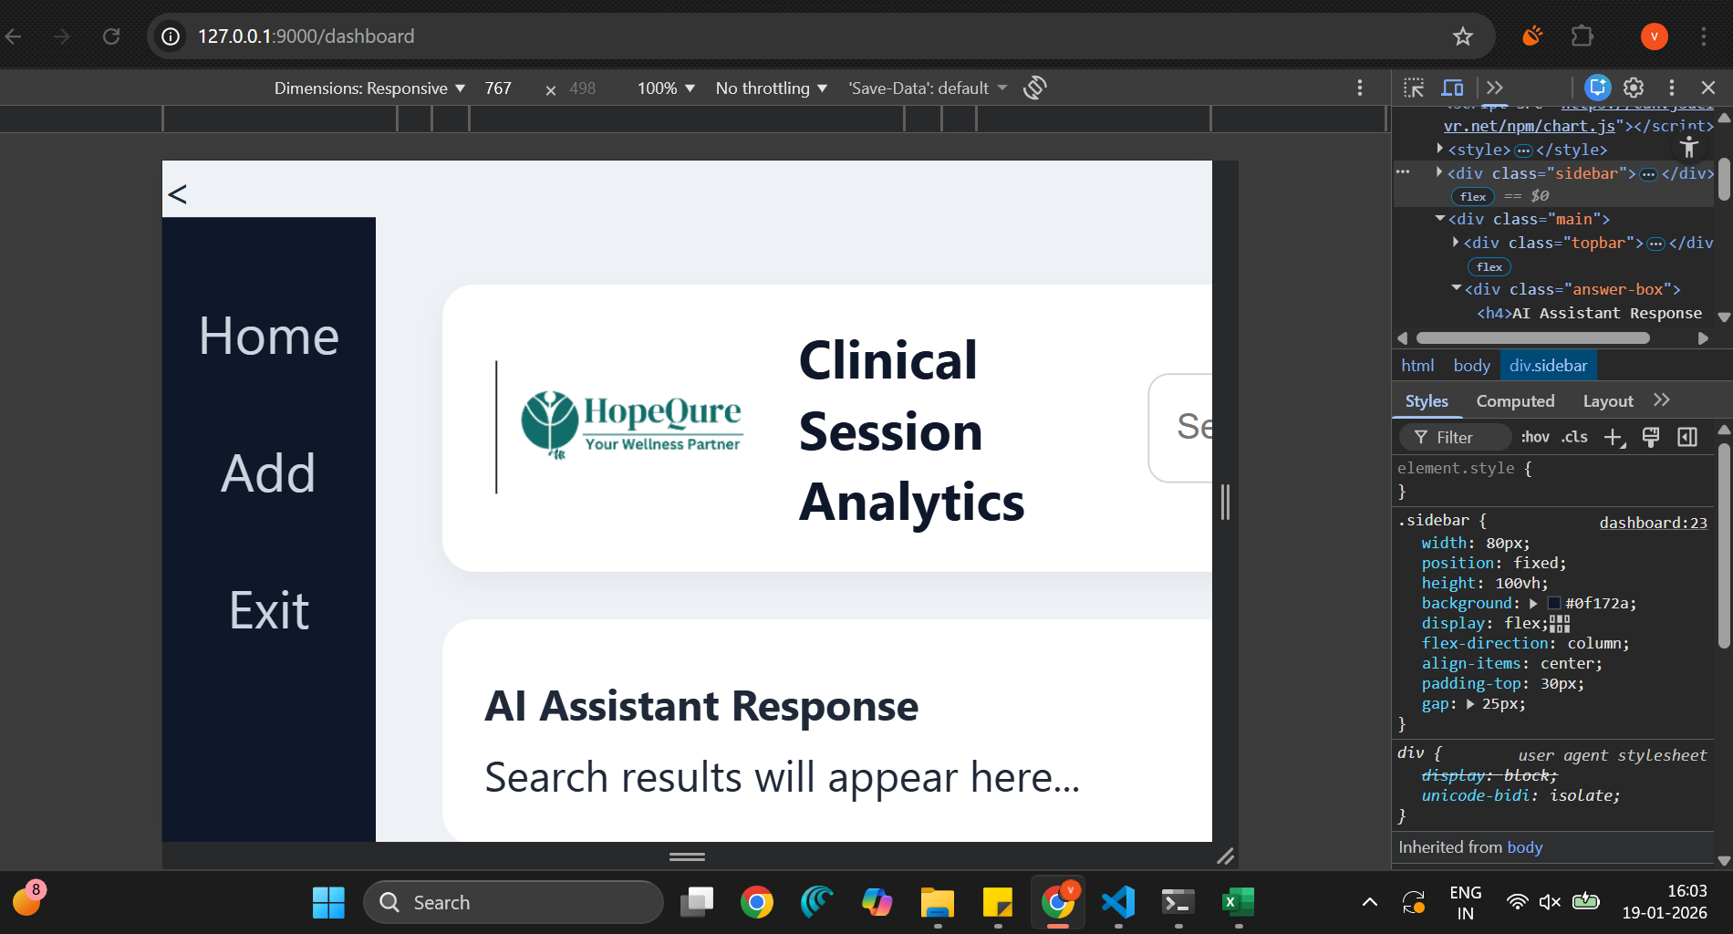 for responsiveness(767 -mobile standard)

<meta name="viewport" content="width=device-width, initial-scale=1.0" /><

Webhook implemented in flask app(sender and reciever now same only),sir also tested,
Webhook URL:
https://apodictically-vitaminic-deja.ngrok-free.dev/webhook-test

Method:
POST

Content-Type:
application/json

Sample Payload:
{
"event": "session.created",
"data": {
"session_id": 27,
"patient_id": 1
}
}
(postman to test)
{for enterprises to send ntoifications of events directly without need to api)

